Software Engineering Lab Task 2

4-12-2024

Eshwar Deshmukh Chavan

HU22CSEN0100999

write any program is goggle colab using hard coding variables, keyboard input, read from a file single input and read from a file multiple set of inputs and save all the versions, debug and fix any errors, push all the versions into your git hub account.

**Steps:**

1. **Hardcoding Variables**:

* Demonstrates the use of predefined values.
* Shows basic variable assignment and printing.

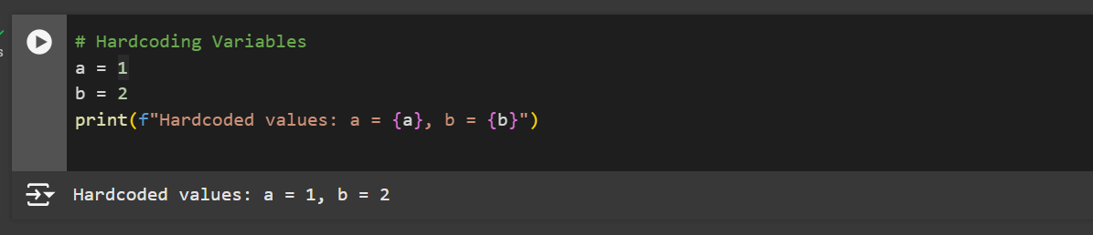

2.**Keyboard Input:**

* Utilizes Python's input() function to accept user data.
* Converts input to the appropriate data type (e.g., integer).

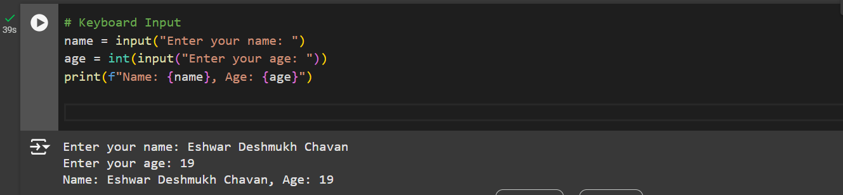

3. **Read From File (Single Input):**

* Reads a single input from a file.
* Handles file not found errors using try-except.

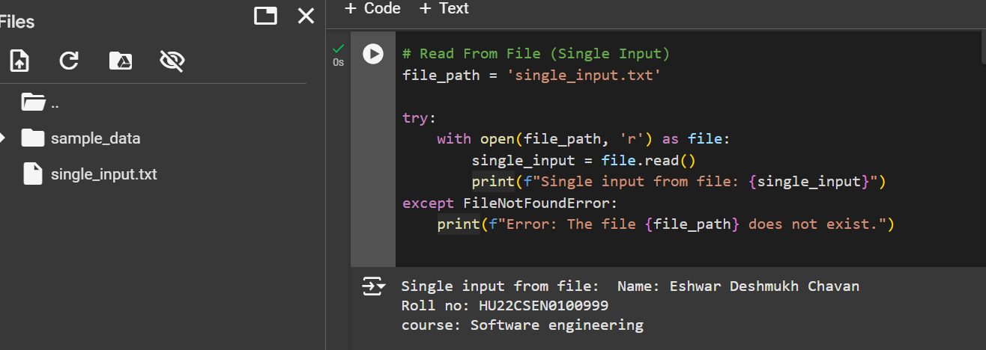

4. **Read From File (Multiple Inputs):**

* Reads multiple inputs from a file.
* Processes each line of the file.
* Handles file not found errors using try-except.

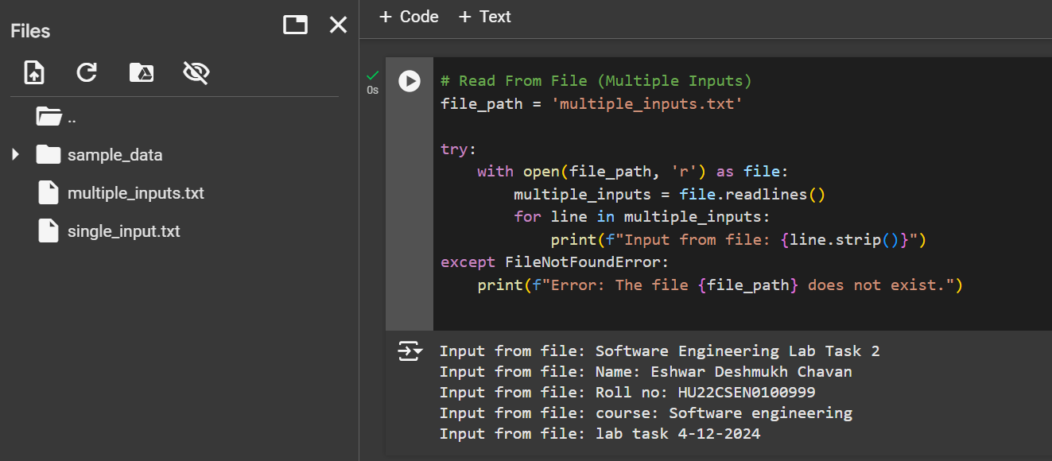

5.**Save All Versions:**

* Each version of the program is saved in different cells.
* Ensures clarity and separation of different tasks.

6. **Debug and Fix Errors:**

* Includes error handling for missing files.
* Ensures robustness by catching and reporting errors.

7. **Push Versions to GitHub:**

* Uses git commands within Colab to push changes.
* Ensures version control and collaboration.

Step 1: Click on file and select option save a copy in GitHub

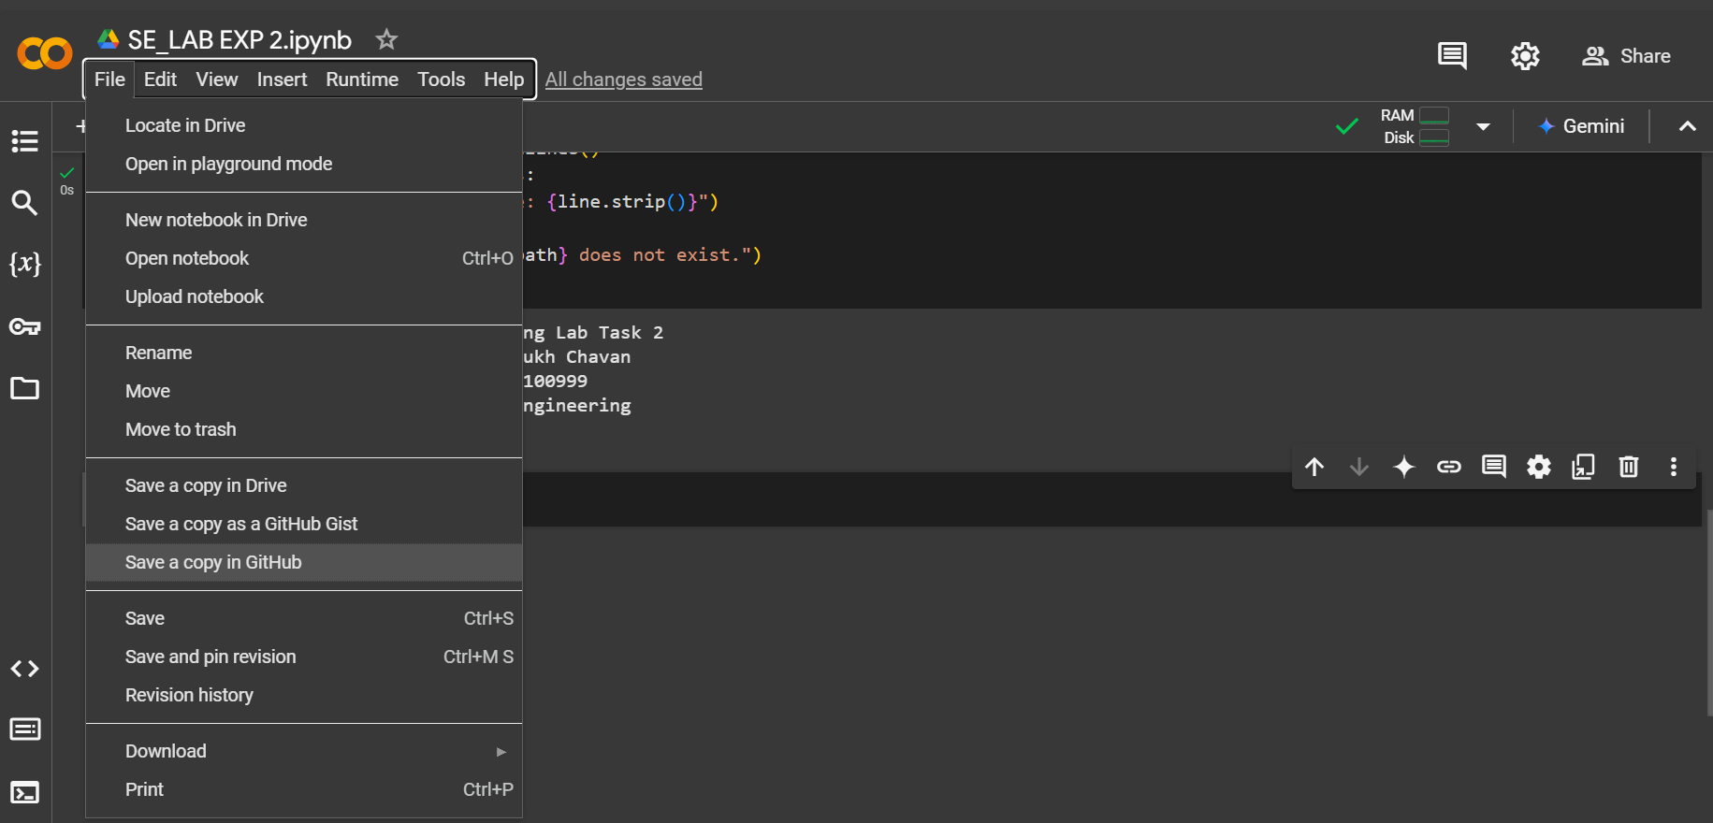

Step 2:Authorize Colaboratory

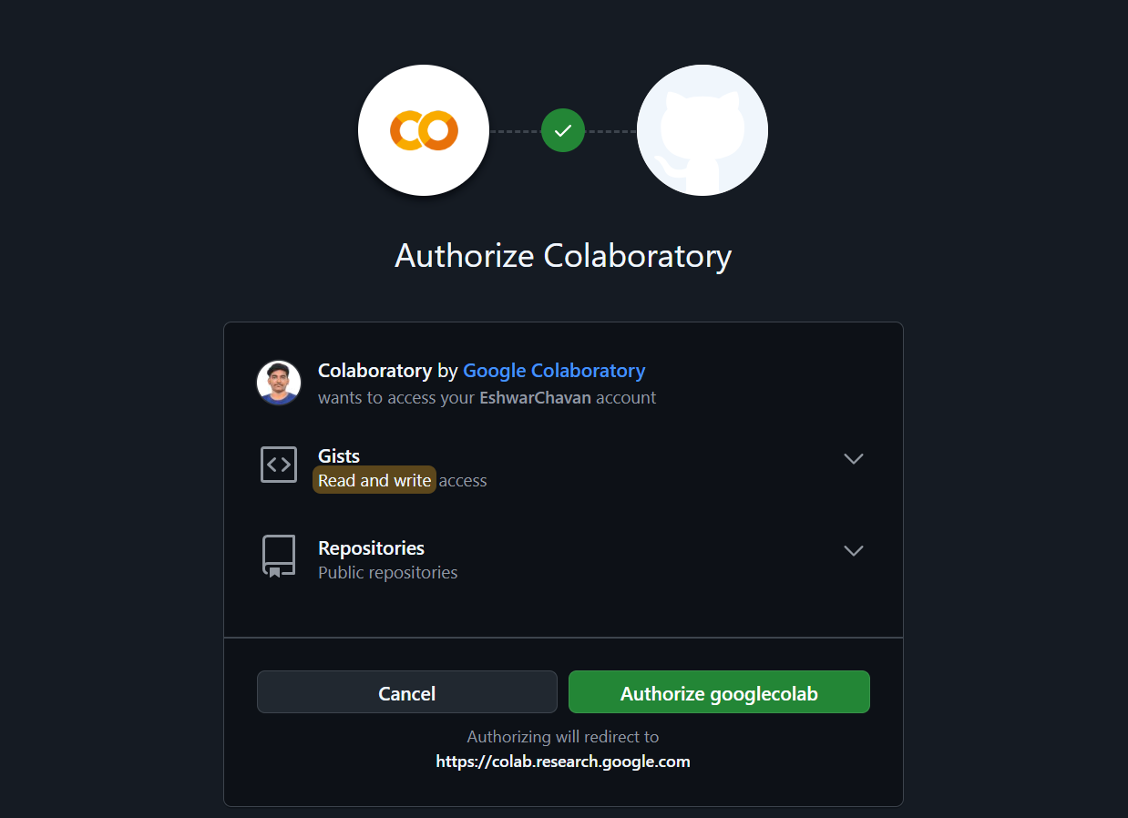

Step 3:Click on ok for copying to GitHub

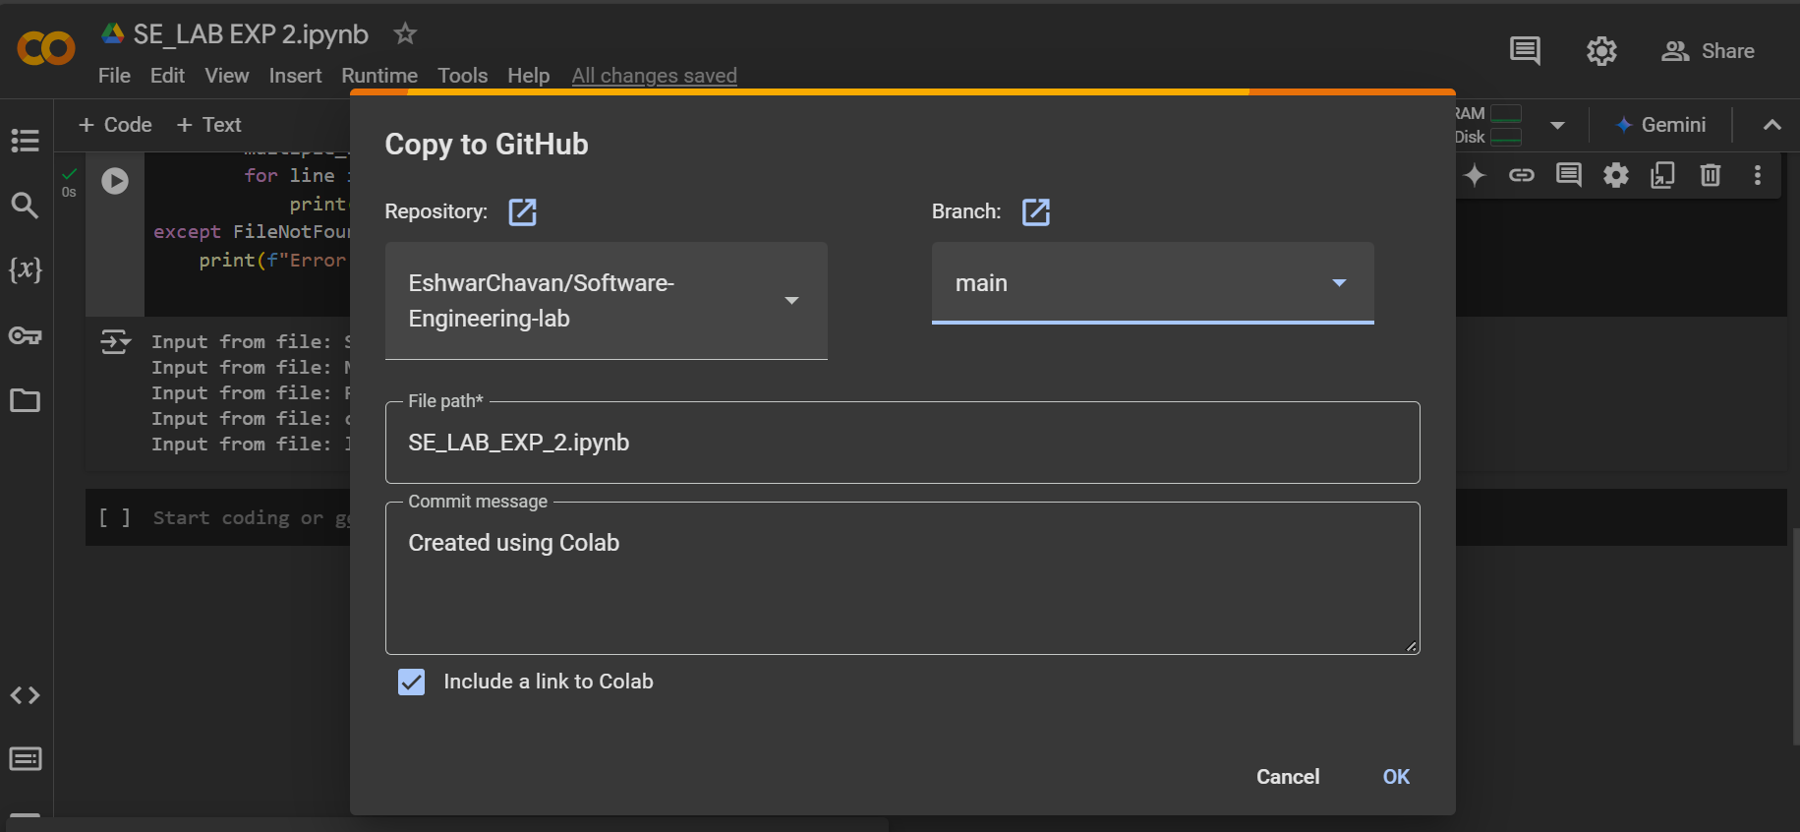

Step 4: Pushed into GitHub

